New Hope
United Methodist Church
September 5, 2021 Labor Day Weekend
We are New Hope United Methodist Church, a Community of Faith that exists for the Glory of God to reach out and welcome people, serve others and equip them with a faith that works in everyday life.

PRELUDE
LIGHTING OF THE CANDLES & RINGING OF BELLS
ANNOUNCEMENTS, GREETINGS, AND RECOGNITION OF GUESTS – Worship Leader
(*INVITES CONGREGATION TO STAND)

*Call to Worship/Blessing of Backpacks:
ONE: Calling all children of the Living God: the gospel is good news for every age and every stage.
ALL: Let us worship together, the young and the old.
ONE: The good news is proclaimed in God’s words, and also with crayons, silly songs, snacks, and rest time.
ALL: Let us worship together, every generation.
ONE: After months of learning behind screens
or separated by dividers and physical space,
ALL: Let us worship together, with our family of faith.
ONE: We may still feel uncertain, seeing so many faces again, but we come together seeking God’s peace in this beautiful community.
ALL: Let us worship together, united in Christ.

*Opening Hymn (track 1) #369, Blue Hymnal
“Blessed Assurance” (v. 1 & 2)

Opening Prayer (in unison): As we gather here in your name, O Christ, you are already among us. Keep us open to your presence in us and around us that we may grow closer to you. Amen.

Hymn 454, Blue Hymnal
“Open My Eyes, That I May See”

Scripture Mark 7: 24-37 (NT p. 40)

Sermon “Giving Our Best” Pastor Ric

Hymn “All Who Hunger” #2126, Black Hymnal

We Share the Lord’s Supper
Invitation Blessing the Bread and Cup
Sharing the Bread and Cup

Prayer of Thanksgiving (in unison)
God of abundance and mercy, we give joyful thanks for your eternal love and healing presence in our celebration of bread and the cup. Bless us, your people, the body of Christ that we may attend faithfully to our call to be your servants, with each other and throughout the world. Amen.

Hymn (track 9) 526, Blue Hymnal
“What A Friend We Have In Jesus” (v. 1 & 2)

Sharing of Joys and Concerns
Pastoral Prayer and The Lord’s Prayer
Our Father, who art in heaven, hallowed be thy name. Thy kingdom come, thy will be done, on earth as it is in heaven. Give us this day our daily bread. And forgive us our trespasses as we forgive those who trespass against us. And lead us not into temptation but deliver us from evil. For thine is the kingdom, and the power, and the glory, forever. AMEN

Invitation to the Offering
God gives to us continually. In each breath, we receive God’s spirit. Responding to God’s generosity, let us give to God in thanksgiving. Let us receive our offering.

*Doxology #84, Blue Hymnal “Thank You, Lord” (2x)

*Prayer of Thanksgiving (in unison): We dedicate to you, generous God, our lives. Receive these offerings as a sign of our gratitude and commitment. Amen.

*Closing Hymn #664, Blue Hymnal
“Sent Forth by God’s Blessings”

*Benediction
In living for others, we find life. In loving others, we find the love of God. In seeking justice, we find and create peace. In finding Jesus, we find the example of how we are to live. Go, loving Jesus, loving your neighbor as yourself, and live into the way of Christ. Amen.
Thank you for worshipping with us today!
New Hope
United Methodist Church
W7797 Center Road, Glenbeulah, WI 53023-1508
Worship at 10:30 am – September 5, 2021

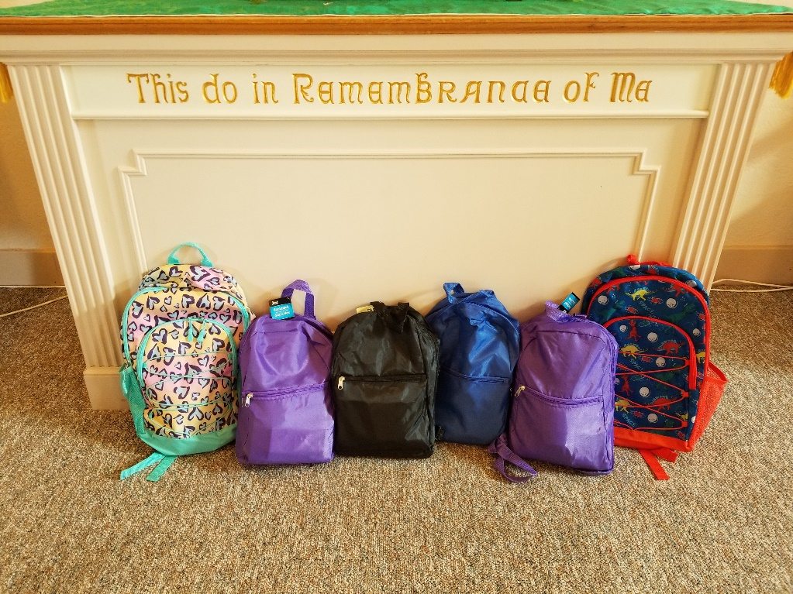

Pastor: Ric Olson pastor@gbnewhopeumc.org (920) 980-8302
If you are in need of pastoral care, please call the pastor, or call the New Hope Church Office at 920-526-3372.

Welcome to New Hope United Methodist Church
Church Phone: 920-526-3372
Church e-mail address: newhopeumc@gbnewhopeumc.org
Attendance on 8/29: 11 Offering: $ 85.00

ANNOUNCEMENTS:
Send announcements to: Nancy at nancy@gbnewhopeumc.org
Prayer Chain Requests: Please call Kaye Hau (920-526-3882)
Next Administrative Board Meeting: Monday, Sept. 13th @ 6:30 PM
Next Communion Sunday: October 3rd World Communion Sunday
FYI: All loose coins and single dollar bills will be given to missions.

UPCOMING EVENTS:
- Please mark your calendar for Sunday, September 26th for a celebration of our 170th Anniversary! Please RSVP to nancy@gbnewhopeumc.org so we know how many to prepare for the dinner.

KEEP THEM IN YOUR PRAYERS:
- We keep Martha in our prayers whose mother-in-law passed away, and she went back to Florida to be with her husband. Trying to break up a fight between her dogs, her thumb was broke.
- We keep Faye who fell and broke her elbow in our prayers. She is home now.
- We keep Betty in our prayers who moved to Song Bird Pond in Plymouth recently.

REMINDERS
- Thank you for making a change to begin worship at 10:30 am so that Pastor Ric can comfortably drive here from Waldo Trinity.

Welcome to New Hope United Methodist Church
Church Phone: 920-526-3372
Church e-mail address: newhopeumc@gbnewhopeumc.org
Attendance on 8/29: 11 Offering: $ 85.00

ANNOUNCEMENTS:
Send announcements to: Nancy at nancy@gbnewhopeumc.org
Prayer Chain Requests: Please call Kaye Hau (920-526-3882)
Next Administrative Board Meeting: Monday, Sept. 13th @ 6:30 PM
Next Communion Sunday: October 3rd World Communion Sunday
FYI: All loose coins and single dollar bills will be given to missions.

UPCOMING EVENTS:
- Please mark your calendar for Sunday, September 26th for a celebration of our 170th Anniversary! Please RSVP to nancy@gbnewhopeumc.org so we know how many to prepare for the dinner.

KEEP THEM IN YOUR PRAYERS:
- We keep Martha in our prayers whose mother-in-law passed away, and she went back to Florida to be with her husband. Trying to break up a fight between her dogs, her thumb was broke.
- We keep Faye who fell and broke her elbow in our prayers. She is home now.
- We keep Betty in our prayers who moved to Song Bird Pond in Plymouth recently.

REMINDERS
- Thank you for making a change to begin worship at 10:30 am so that Pastor Ric can comfortably drive here from Waldo Trinity.

NEW HOPE UNITED METHODIST CHURCH 170TH ANNIVERSARY CELEBRATION

Date: September 26, 2021

Worship: 10:30am

Time: 11:30am (After Worship)

Where: Church parking lot
(weather permitting)

-----------------------------------------------------------------

Please RSVP to nancy@gbnewhopeumc.org or complete and return the form below so we know how many to prepare for the dinner. Thank you.

Name: _____________________________________

Number of People Attending: __________________

NEW HOPE UNITED METHODIST CHURCH 170TH ANNIVERSARY CELEBRATION

Date: September 26, 2021

Worship: 10:30am

Time: 11:30am (After Worship)

Where: Church parking lot
(weather permitting)

-----------------------------------------------------------------

Please RSVP to nancy@gbnewhopeumc.org or complete and return the form below so we know how many to prepare for the dinner. Thank you.

Name: _____________________________________

Number of People Attending: __________________

